**Essay analysing the effect of increased oil prices on the aggregate level of supply in the United Kingdom’s economy.**

Following Russia’s invasion of Ukraine, President Joe Biden of the US implemented sanctions on the import of Russian oil (U.S. White House Briefing Room, 2022). Several countries are following this sanction (European Comission, 2022), effectively removing Russia from the international oil market. As Russia is one of the largest exporters of crude oil in the world (OPEC, 2022), the supply of oil has decreased drastically, resulting in increased oil prices. This will affect UK producers as the UK is highly dependent on oil, being a net importer of oil (Harris, 2021). This essay will analyse whether the increase in oil prices slows down the United Kingdom’s economy through analysing the aggregate levels of supply and its output.

The removal of Russian oil from the international market will decrease the supply of oil. For the sake of analysis, one is to assume all other factors remain constant – ceteris paribus. With a decreased supply of oil, the prices will rise as the already scarce product becomes scarcer, making it more profitable to sell. By increasing the price of oil, the cost of production increases. This increased cost is passed on to consumers in the form of increased price (Williams, et al., 2014). As oil is utilized in most if not all production as a factor of production (Department for Business, Energy & Industrial Strategy, 2021) there is a decrease in the overall level of supply in the economy known as a negative shock in aggregate supply.

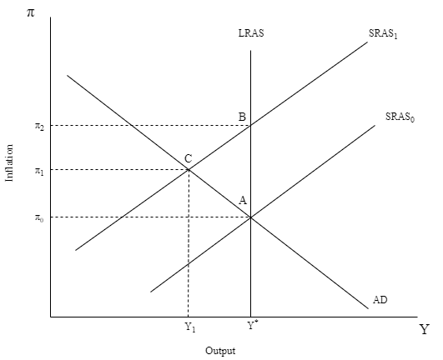

Figure - Aggregate Demand and aggregate supply

Figure 1 showcases this negative shock in aggregate supply through a leftwards shift in the short run aggregate supply curve from SRAS0 to SRAS1. Initially, the economy exists in equilibrium, where the aggregate demand in the economy is equal to the aggregate supply in the short run. At the initial equilibrium output level of Y*, with the decreased SRAS curve SRAS1, there is an increase in price levels, also known as inflation. At the new level of inflation at point B, less will be demanded than is supplied for the given price levels, causing a new equilibrium to be established at point C, with decreased output of Y1 and inflation at π1. The new equilibrium is at a production level below the potential output Y* shown by the long run aggregate supply curve LRAS. This negative output gap between Y* and Y1 causes inflation to decrease from the positive relationship between the output gap and inflation (Claus, 2000), however, this only occurs towards the long run. Meaning, ultimately, the original equilibrium at A is re-established, but in the short run, the economy operates at point C.

The United Kingdom’s economy will slow down in the short run since output moves to Y1 from its potential output at Y*. The slowdown in economic growth comes from the negative relationship between inflation and economic growth (Barro, 1995). Also, as output is a measure of GDP and economic growth discusses the growth of GDP, at a lower output level, Y1, economic growth declines. If the exclusion of Russian oil in the international market becomes permanent, the LRAS curve will shift leftwards, and the UK’s economy will be in equilibrium at a higher level of inflation and lower output. To avoid the worse equilibrium at point C, while excluding Russia, the quantity of oil otherwise supplied by Russia must be provided by another country to maintain the UK’s initial equilibrium at point A. However, Russia exports such a large amount of crude oil that it is unlikely that other countries can replace their supply. Thus, maintaining Russian supply of oil is crucial to prevent a slowdown in the UK economy. To reintroduce Russia to the oil market, achieving peace in Ukraine is crucial. If peace cannot be achieved and Russia is permanently excluded from the oil market, the UK will see a permanent decrease in economic growth as their potential output will be moved from Y* to Y1.

The AD/AS model has shown that the increase in oil prices increase the level of inflation and decreases output in the short run. Thus, there is an economic slowdown in the short run. If Russian oil is permanently excluded from the international market, the economy will permanently slow down, as potential output is decreased. Bringing output back to initial equilibrium can only be achieved by reintroducing the quantity supplied of Russian oil. Thus, peace in Ukraine is crucial to avoid a permanent slowdown in the UK’s economy.

# Bibliography

Barro, R. J., 1995. Inflation and Economic Growth. *NBER Working Paper Series.*

Claus, I., 2000. Is the Output Gap a Useful Indicator of Inflation. 05 April.

Department for Business, Energy & Industrial Strategy, 2021. *UK ENERGY BRIEF 2021,* s.l.: Department for Business, Energy & Industrial Strategy.

European Comission, 2022. *Eruopean Comission.* [Online]   
Available at: https://ec.europa.eu/commission/presscorner/detail/en/statement_22_2281  
[Accessed 05 April 2022].

Harris, K., 2021. *DUKES 2021 Chapter 1: Energy,* s.l.: U.K. Department for Business, Energy & Industrial Strategy.

OPEC, 2022. *OPEC Monthly Oil Market Report,* Vienna: OPEC.

U.S. White House Briefing Room, 2022. *White House.* [Online]   
Available at: https://www.whitehouse.gov/briefing-room/statements-releases/2022/03/08/fact-sheet-united-states-bans-imports-of-russian-oil-liquefied-natural-gas-and-coal/#:~:text=Today%2C%20President%20Biden%20will%20sign,his%20needless%20war%20of%20choice.  
[Accessed 05 April 2022].

Williams, I. et al., 2014. *Cost pass-through: theory, measurement, and potential policy implications,* London: RBB.